3

name class

Vocabulary

Look at the picture. Choose the correct answers.
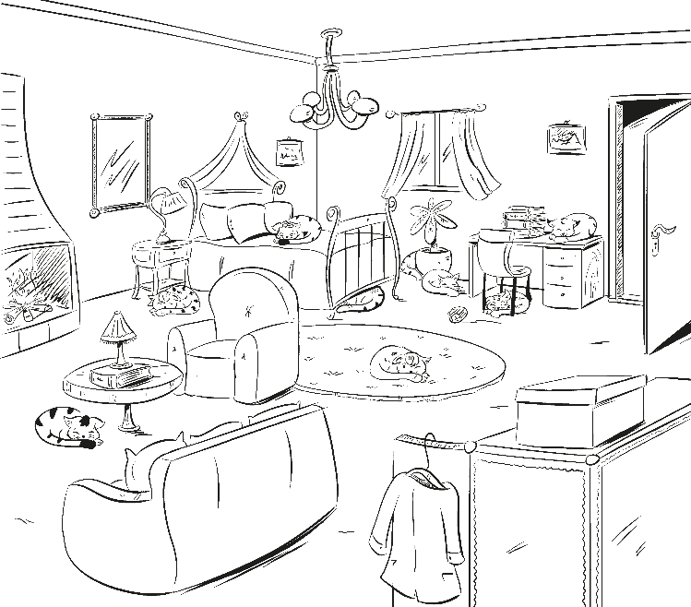
E
B
C
D
A

  - Look at Cat A. It’s in / in front of the bedroom.
English Class A1 © Pearson Central Europe 2017
  - Look at Cat B. It’s under / on the desk.
  - Look at Cat C. It’s next / under the chair.
  - Look at Cat D. It’s next / in front of to the table.
  - Look at Cat E. It’s in front / on of the plant.
/ 4
PHOTOCOPIABLE

Look at the picture. Complete the words with the endings from the box.
-ofa -ed -chair -ushion -amps -arpet -ardrobe

- bed

s
- c s
- arm 4 w
- c
- l
/ 6

Grammar

3 Circle the correct answers.

0 There are / There is a table in the kitchen.
0 There isn’t / There aren’t a table in the kitchen.
- Is there / Are there a table in the kitchen?
- There is / There are twenty chairs in the classroom.
- Is there / Are there a phone on the table?
- There is / There are two beds in the bedroom.
- There is / There are a desk in the bedroom.
English Class A1 © Pearson Central Europe 2017
- There is / There are a rat behind the door.
- Are there / Is there four people at home?
/ 6

4 Make positive sentences, negative sentences or questions.

- there / a rat / is
There is a rat in the garage!
- isn’t / a ruler / there
on the table.
- are / students / there / any
PHOTOCOPIABLE
in the classroom?
- is / in / a television / there /
in your bedroom?
- there / are / four / eggs
in the fridge.
/ 4

Complete the dialogue. Use the words from the boxes.
some any a

Sally: This is my new house. There’s 0a big garden.
Marina: Are there 1 trees in the garden?
Sally: Yes, there are 2 trees. There are ﬂowers too.
a isn’t There

Marina: Is your bedroom big?
Sally: Yes, it is. There’s a bed, a desk and a chair.
3 are four posters on the wall too.
Marina: Is there 4 games console?
Sally: No, there 5 , but there’s a computer!

Speaking

Complete the dialogue with the words in the box.
A: Hello. Please 0come in.
B: Thank you.
A: 1 you like a sandwich?
B: Yes, 2 .
3 the bathroom, please?
A: It’s 4 .
It’s next to Andrew’s bedroom.
5 me show you.
B: Thanks.

/ 5

come Let please upstairs Where’s Would
PHOTOCOPIABLE
English Class A1 © Pearson Central Europe 2017
/ 5

Vocabulary | / 10 | Speaking | / 5
Grammar | / 15 | Your total score | / 30

