Name: Class:

Vocabulary
1 Look at the picture. Write the words.
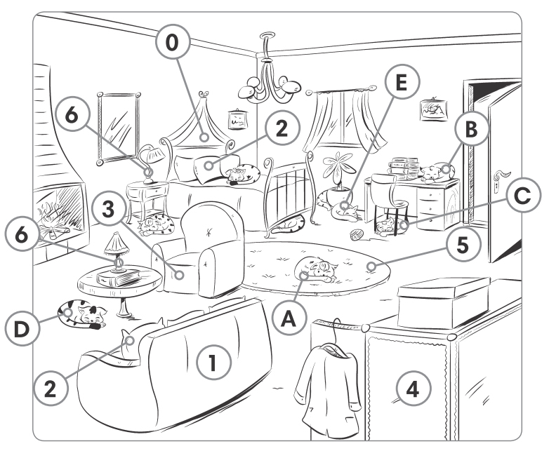
0 bed
1 s
2 c s
3 a
4 w
5 c
6 l s
/ 6
2 Look at the picture in Exercise 1. Complete the answers with prepositions of place.
Where’s ...?
0 Cat A? It’s in the bedroom.
1 Cat B? It’s the desk.
2 Cat C? It’s the chair.
3 Cat D? It’s to the table.
4 Cat E? It’s of the plant.
/ 4

Grammar
3 Complete the sentences. Use there is / there are in the positive [✓], negative [✗] or question [?] form.
0 There is a table in the kitchen. ✓
0 There isn’t a table in the kitchen. ✗
0 Is there a table in the kitchen? ?
1 twenty chairs in the classroom. ✓
2 a phone on the table? ?
3 two beds in the bedroom. ✗
4 a desk in the bedroom. ✓
5 a rat behind the door. ✗
6 four people at home? ?
/ 6
4 Make positive sentences, negative sentences or questions.
0 there / is / the garage / a rat / in / !
There is a rat in the garage!
1 on / isn’t / a ruler / there / the table / .

2 in / students / there / any / the classroom / are / ?

3 bedroom / is / in / a television / there / your / ?

4 there / the fridge / are / four / in / eggs / .

/ 4
5 Complete the dialogue. Use there, isn’t, a, any.
Sally: This is my new house. There’s ⁰ a big garden.
Marina: Are there ¹ trees in the garden?
Sally: No, there aren’t ² trees. The garden is too small for trees. But the house is big.
Marina: Is your bedroom big?
Sally: Yes, it is. There’s a bed, a desk and a chair. ³ are four posters on the wall too.
Marina: Is there ⁴ games console?
Sally: No, there ⁵ , but there’s a computer!
/ 5

Speaking
6 Complete the dialogue with the words in the box. There is one extra word.
come let please upstairs what’s where’s would
A: Hello. Please ⁰ come in.
B: Thank you.
A: ¹ you like a sandwich?
B: Yes, ² . ³ the bathroom, please?
A: It’s ⁴ . It’s next to Andrew’s bedroom. ⁵ me show you.
B: Thanks.
/ 5

Vocabulary / 10
Grammar / 15
Speaking / 5
Your total score: / 30

